3.89: a) The trajectory of the projectile is given by Eq. (3.27), with 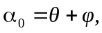 and the equation describing the incline is 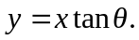 Setting these equal and factoring out the 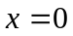 root (where the projectile is on the incline) gives a value for 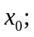 the range measured along the incline is
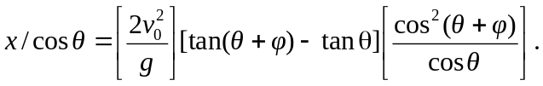
b) Of the many ways to approach this problem, a convenient way is to use the same sort of "trick", involving double angles, as was used to derive the expression for the range along a horizontal incline. Specifically, write the above in terms of 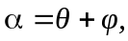 as
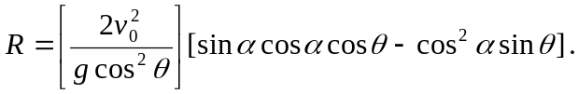
The dependence on and hence is in the second term. Using the identities this term becomes
This will be a maximum when 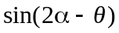 is a maximum, at 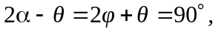 or 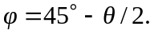 Note that this reduces to the expected forms when 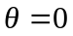 (a flat incline, 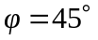 and when 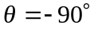 (a vertical cliff), when a horizontal launch gives the greatest distance).

